**Activity_main.xml:**  
  
<?xml version="1.0" encoding="utf-8"?>  
<RelativeLayout xmlns:android="http://schemas.android.com/apk/res/android"  
 xmlns:app="http://schemas.android.com/apk/res-auto"  
 xmlns:tools="http://schemas.android.com/tools"  
 android:layout_width="match_parent"  
 android:layout_height="match_parent"  
 tools:context=".MainActivity">  
  
 <GridLayout  
 android:layout_width="match_parent"  
 android:layout_height="match_parent"  
 android:rowCount="3"  
 android:columnCount="2">  
  
 <androidx.cardview.widget.CardView  
 android:layout_width="wrap_content"  
 android:layout_height="235dp"  
 android:layout_row="0"  
 android:layout_column="0"  
 android:layout_columnWeight="1">  
  
 <LinearLayout  
 android:layout_width="wrap_content"  
 android:layout_height="wrap_content"  
 android:layout_gravity="center_vertical|center_horizontal"  
 android:gravity="center"  
 android:orientation="vertical">  
  
 <ImageView  
 android:layout_width="wrap_content"  
 android:layout_height="wrap_content"  
 android:src="@drawable/baseline_home_24" />  
  
 <TextView  
 android:layout_width="wrap_content"  
 android:layout_height="wrap_content"  
 android:text="Home" />  
 </LinearLayout>  
 </androidx.cardview.widget.CardView>  
  
 <androidx.cardview.widget.CardView  
 android:layout_height="wrap_content"  
 android:layout_width="wrap_content"  
 android:layout_column="1"  
 android:layout_row="0"  
 android:layout_columnWeight="1"  
 android:layout_rowWeight="1">  
  
 <LinearLayout  
 android:layout_width="wrap_content"  
 android:layout_height="wrap_content"  
 android:layout_gravity="center_vertical|center_horizontal"  
 android:orientation="vertical"  
 android:gravity="center">  
 <ImageView  
 android:layout_width="wrap_content"  
 android:layout_height="wrap_content"  
 android:src="@drawable/baseline_contact_page_24"/>  
 <TextView  
 android:layout_width="wrap_content"  
 android:layout_height="wrap_content"  
 android:text="Contacts" />  
 </LinearLayout>  
 </androidx.cardview.widget.CardView>  
  
 <androidx.cardview.widget.CardView  
 android:layout_width="133dp"  
 android:layout_height="wrap_content"  
 android:layout_row="1"  
 android:layout_rowWeight="1"  
 android:layout_column="0"  
 android:layout_columnWeight="1"  
 android:background="@drawable/ic_launcher_background">  
 <LinearLayout  
 android:layout_width="wrap_content"  
 android:layout_height="63dp"  
 android:layout_gravity="center_vertical|center_horizontal"  
 android:gravity="center"  
 android:orientation="vertical">  
 <ImageView  
 android:layout_width="wrap_content"  
 android:layout_height="wrap_content"  
 android:src="@drawable/baseline_account_circle_24" />  
 <TextView  
 android:layout_width="wrap_content"  
 android:layout_height="wrap_content"  
 android:text="Account" />  
 </LinearLayout>  
 </androidx.cardview.widget.CardView>  
  
 <androidx.cardview.widget.CardView  
 android:layout_height="wrap_content"  
 android:layout_width="wrap_content"  
 android:layout_column="1"  
 android:layout_row="1"  
 android:layout_columnWeight="1"  
 android:layout_rowWeight="1">  
 <LinearLayout  
 android:layout_width="wrap_content"  
 android:layout_height="wrap_content"  
 android:orientation="vertical"  
 android:gravity="center"  
 android:layout_gravity="center_vertical|center_horizontal">  
 <ImageView  
 android:layout_width="wrap_content"  
 android:layout_height="wrap_content"  
 android:src="@drawable/baseline_history_24"/>  
 <TextView  
 android:layout_width="wrap_content"  
 android:layout_height="wrap_content"  
 android:text="Transaction History"/>  
 </LinearLayout>  
 </androidx.cardview.widget.CardView>  
 <androidx.cardview.widget.CardView  
 android:layout_height="wrap_content"  
 android:layout_width="wrap_content"  
 android:layout_column="0"  
 android:layout_row="2"  
 android:layout_columnWeight="1"  
 android:layout_rowWeight="1">  
 <LinearLayout  
 android:layout_width="wrap_content"  
 android:layout_height="wrap_content"  
 android:orientation="vertical"  
 android:gravity="center"  
 android:layout_gravity="center_vertical|center_horizontal">  
 <ImageView  
 android:layout_width="wrap_content"  
 android:layout_height="wrap_content"  
 android:src="@drawable/baseline_add_card_24"/>  
 <TextView  
 android:layout_width="wrap_content"  
 android:layout_height="wrap_content"  
 android:text="Add Card"/>  
 </LinearLayout>  
 </androidx.cardview.widget.CardView>  
  
 <androidx.cardview.widget.CardView  
 android:layout_width="wrap_content"  
 android:layout_height="231dp"  
 android:layout_row="2"  
 android:layout_column="1"  
 android:layout_columnWeight="1"  
 android:layout_margin="2dp"  
 app:cardCornerRadius="4dp">  
 <LinearLayout  
 android:layout_width="wrap_content"  
 android:layout_height="wrap_content"  
 android:layout_gravity="center_vertical|center_horizontal"  
 android:gravity="center"  
 android:orientation="vertical">  
 <ImageView  
 android:layout_width="wrap_content"  
 android:layout_height="wrap_content"  
 android:src="@drawable/baseline_read_more_24" />  
 <TextView  
 android:layout_width="wrap_content"  
 android:layout_height="wrap_content"  
 android:text="About Us" />  
 </LinearLayout>  
 </androidx.cardview.widget.CardView>  
 </GridLayout>  
</RelativeLayout>

MainActivity.java:  
  
package com.example.gridlayout;  
  
import androidx.appcompat.app.AppCompatActivity;  
  
import android.os.Bundle;  
  
public class MainActivity extends AppCompatActivity {  
  
 @Override  
 protected void onCreate(Bundle savedInstanceState) {  
 super.onCreate(savedInstanceState);  
 setContentView(R.layout.*activity_main*);  
 }  
}

VIVA:  
Android Layout is used to define the user interface that holds the UI controls or widgets that will appear on the screen of an android application or activity screen. Generally, every application is a combination of View and ViewGroup. All the elements in a layout are built using a hierarchy of View and ViewGroup objects.

A View is defined as the user interface which is used to create interactive UI components such as TextView, ImageView, EditText, RadioButton, etc., and is responsible for event handling and drawing. They are Generally Called Widgets.

**Linear Layout:**

A LinearLayout arranges its child views either horizontally or vertically in a single direction. You can specify the orientation using the android:orientation attribute.

Code:

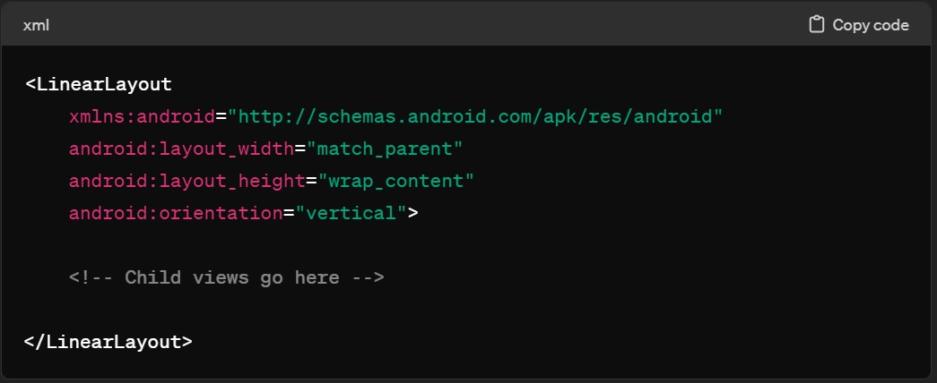

**Relative Layout:**  
A RelativeLayout allows you to position child views relative to each other or to the parent layout. You can use various attributes like android:layout_alignParentTop, android:layout_below, etc., to define the positioning.

Code:  
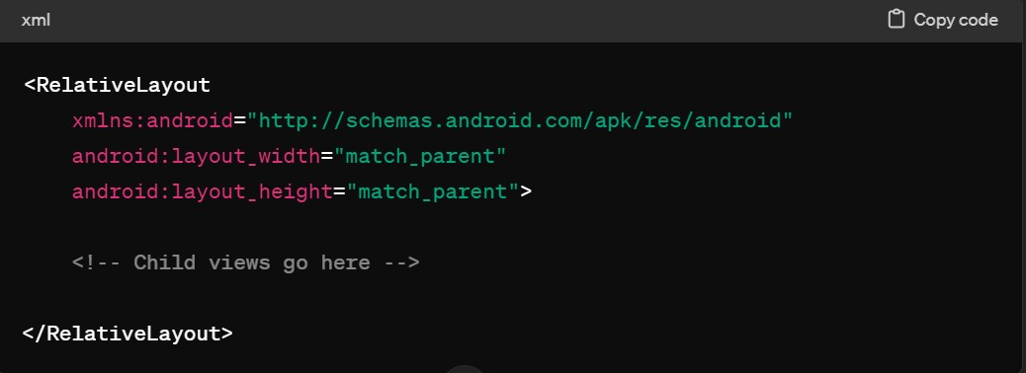

**Constraint Layout:**  
A ConstraintLayout is a flexible layout manager that allows you to create complex UI designs with a flat view hierarchy. It uses constraints to define the position and size of child views relative to each other and to the parent layout.

Code:

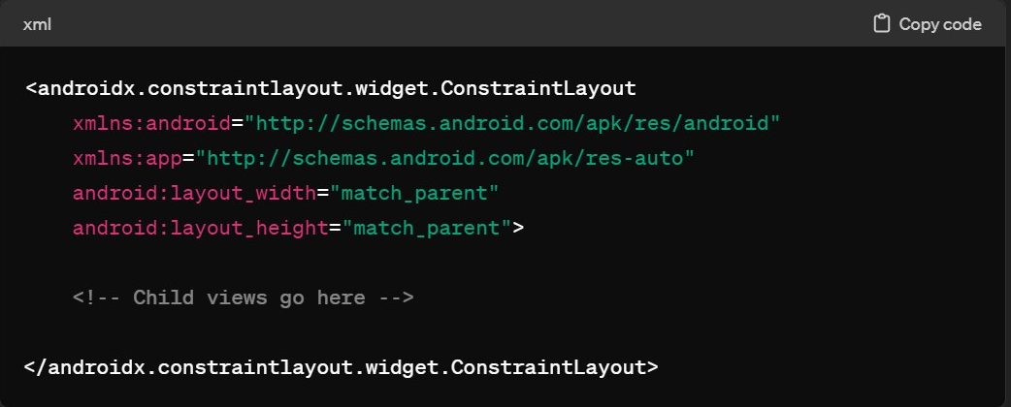

**Table Layout:**  
A TableLayout organizes its child views into rows and columns, similar to an HTML table. You can use TableRow to define the rows and android:layout_span to span columns.

Code:  
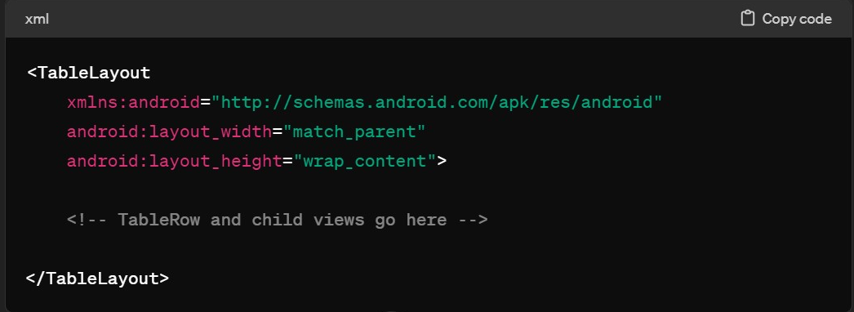

**Frame Layout:**  
A FrameLayout is designed to display a single item at a time, stacking child views on top of each other. It is commonly used for fragments and overlays.

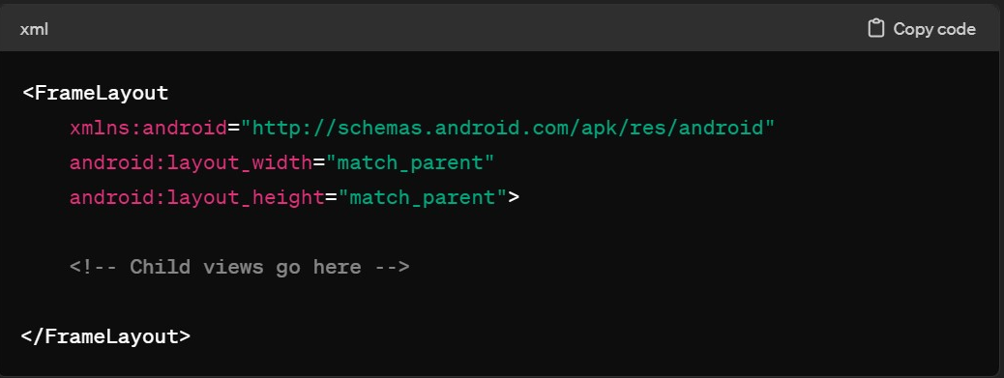

**Scroll View:**

A ScrollView is used to create a scrollable view when the content of the layout exceeds the screen size. It can contain only one child view, which should be a layout or a container.

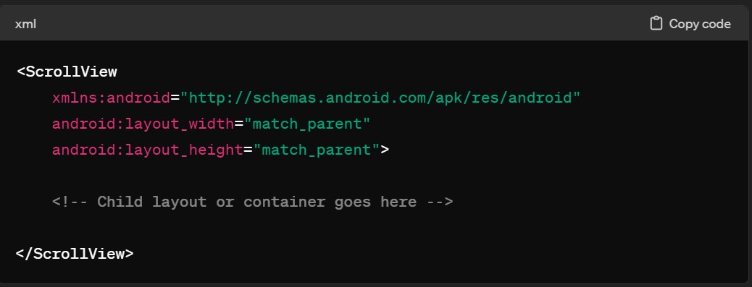

**Grid Layout:**

A GridLayout arranges its child views in a grid of rows and columns. It is useful for creating grid-based UI designs where each cell can contain a different UI component.

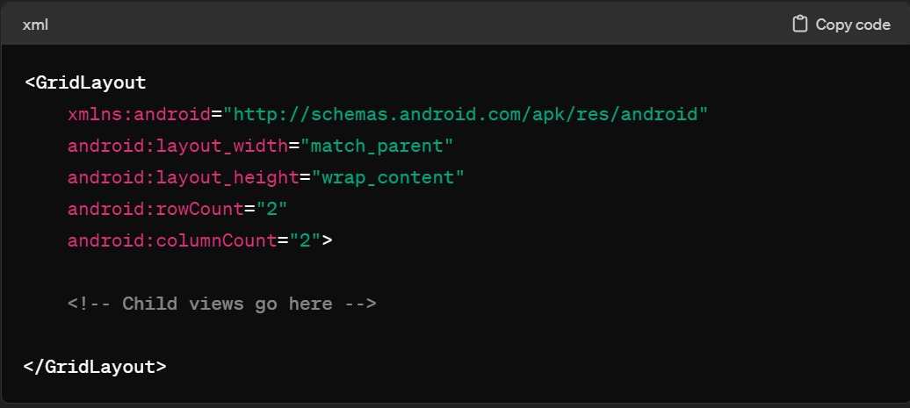

In Android development, match_parent and wrap_content are layout width and height attributes used to define the size of a UI component within a layout.

The match_parent attribute sets the width or height of a UI component to match the parent container's width or height. This means the component will occupy all the available space along the specified axis within its parent layout.

The wrap_content attribute sets the width or height of a UI component to fit the content it contains. This means the component will adjust its size to wrap around the content without exceeding the content's dimensions.

<LinearLayout

xmlns:android="http://schemas.android.com/apk/res/android"

android:layout_width="match_parent"

android:layout_height="wrap_content"

android:orientation="vertical">

<Button

android:id="@+id/button1"

android:layout_width="match_parent"

android:layout_height="wrap_content"

android:text="Button 1"/>

<Button

android:id="@+id/button2"

android:layout_width="wrap_content"

android:layout_height="wrap_content"

android:text="Button 2"/>

</LinearLayout>

Button 1 will stretch horizontally to fill the entire width of the LinearLayout (match_parent for width) and adjust its height to fit the content (wrap_content for height).

Button 2 will adjust both its width and height to fit the content (wrap_content for both width and height).

**Points to remember for code:**

**grid layout -> width, height -> match_parent**

**1st:**

**1st card view -> width = wrap content -> height =235dp**

**1st Linear Layout -> width, height = wrap_content**

**1st Image View -> width, height=wrap_content**

**1st Text View -> width, height= wrap content**

**2nd:  
2nd card view -> width,height = wrap content**

**2nd Linear Layout -> width, height = wrap_content**

**2nd Image View -> width, height = wrap_content**

**2nd Text View -> width, height= wrap content**

**3rd:  
3rd card view -> width=133dp -> height = wrap content**

**3rd Linear Layout -> width = wrap_content, height = 63dp**

**3rd Image View -> width, height = wrap_content**

**3rd Text View -> width, height= wrap content**

**4th:**

**4th card view -> width=wrap_content -> height = wrap content**

**4th Linear Layout -> width = wrap_content, height = wrap_content**

**4th Image View -> width, height = wrap_content**

**4th Text View -> width, height= wrap content**

**5th:**

**5th card view -> width=wrap_content -> height = wrap content**

**5th Linear Layout -> width = wrap_content, height = wrap_content**

**5th Image View -> width, height = wrap_content**

**5th Text View -> width, height= wrap content**

**6th:**

**6th card view -> width=wrap_content -> height = 231dp**

**6th Linear Layout -> width = wrap_content, height = wrap_content**

**6th Image View -> width, height = wrap_content**

**6th Text View -> width, height= wrap content**